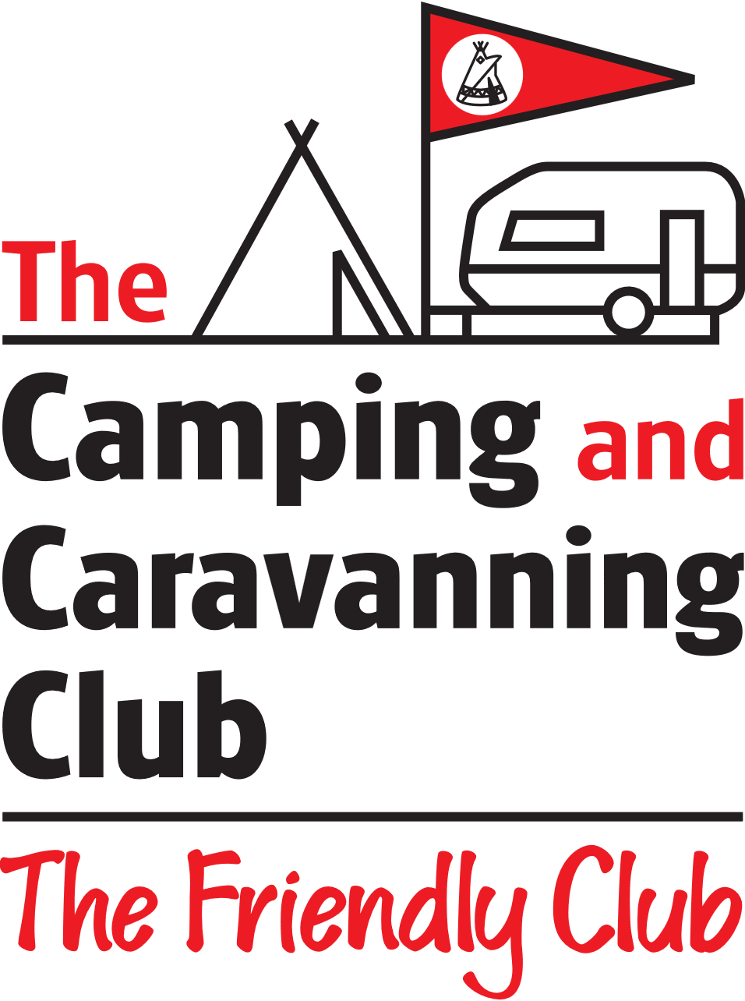_______________________________________________________________________________________________
21st-24th JUNE 2024

22nd-25th April 2022

LODDON DA
THRUXTON EVENT
BOOKING FORM

Please complete one form per unit/pitch.
NAME …………………………………………………………………………
ADDRESS …………………………………………………………………………………………………………………………………………
…………………………………………………………………………………………………………………………………………
……………………………………..
CLUB NUMBER ……………………………
ON SITE CONTACT PHONE NUMBER ……………………………………………
UNIT TYPE & APPROX LENGTH ………………………………………………………………………………………..
SITE OPENS AT 12:00Hrs ON FRIDAY AND CLOSES AT 12:00 Hrs ON MONDAY
ANTICIPATED ARRIVAL DATE AND TIME ………………………………………………………………………….
NUMBER OF GUESTS IN PARTY …………

Package price £64.00 ( Includes Dedicated site area, Two Adult tickets allowing circuit admission, covering both the Saturday and Sunday . Children 15 and Under FOC.
Additional Adult circuit admission tickets £32.00
PAYMENT
Payment can be made direct to the Loddon DA Bank Account
Loddon Camping & Caravanning Club
Sort Code:- 30-98-97 Account No:- 72763762
Or by cheque or cash at the event.

Please Return the completed form to:- justmotorsport@gmail.com
Many Thanks,
Dennis Carter

